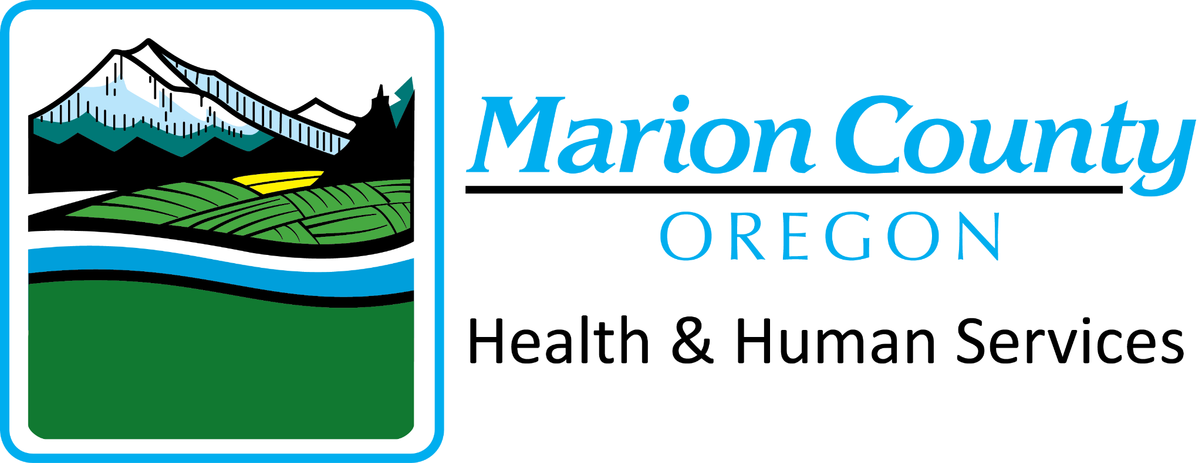
2024 Healthy Choices Video Contest

PRIZE BREAKDOWN:
- 1st place: $1,000 total. $500 gift card to participants, $500 gift card to the eligible sponsoring organization (see page 2 for details).
- 2nd & 3rd place: $500 total. $250 gift card to participants, $250 gift card to the eligible sponsoring organization.
- Multicultural Inclusivity Award: A special honor and extra credit points will be given to videos submitted in a language other than English, American Sign Language, or representing persons with a disability.
Step 1: Create Your Team.
- Group of 2-4 friends (14-18 years old).
- Adult advisor at school or from community organization.
Step 2: Pick a message for your video that focuses on healthy choices.
- Video should include resources for youth.
- The video should be from youth voice and youth perspective.
- Be creative! Potential video ideas:
  - A video about a time you’ve been faced with a tough choice and chose the healthy route instead.
  - Make a mini documentary on something you’ve accomplished & the work it took to get there.
  - Have a talk show/interview style video about healthy choices.
  - Create a PSA to other youth on how healthy choices impact your future.
  - Share an informational video on ways you calm down when stressed.
Step 3: Create Your Video.
- 1-4 minutes run time
- Needs to depict healthy activities & messaging.

Do not imitate gambling, alcohol, or drug use.

Do not show depictions of violence or use inappropriate language.

Use person centered language (example: person with a gambling problem or person with a drinking disorder, NOT problem gambler or alcoholic).
- Videos in languages other than English will be accepted! If submitting a video in another language, please have English subtitles accompany your film.

Step 4: Submit Your Video, Registration and Photo Release Forms
- Upload your video by midnight on April 30th 2024. Email Hejohnson@co.marion.or.us to receive a link to upload your video.
- Submit completed registration form and photo release forms to Heidi Johnson, Hejohnson@co.marion.or.us on or before April 30, 2024.

See following pages for additional contest details, the registration form and photo release form.
For questions or more info, please contact Heidi Johnson, Hejohnson@co.marion.or.us

IMPORTANT DATES:
April 30, 2024: | Submit your video and release/permission forms to Hejohnson@co.marion.or.us
May 3, 2024: | Top Submissions (judged by committee) will be posted for voting. Share with your family and friends.
May 10, 2024: | Public voting ends.
May 13, 2024: | Official winners announced!
May 18, 2024: | Red carpet award event for top 3 videos

ELIGIBILITY:
The contest is open to high school age teenagers (14-18 years old) living in Marion County or Polk County, Oregon, and/or affiliated to an eligible sponsoring organization based in either county. Eligible sponsoring organizations include Marion and Polk County based school districts and affiliated classes, clubs, sports teams, and groups; or a not-for-profit community-based organization that serves youth. Exceptions may apply, contact us for more information. Individual entries submitted will automatically be ineligible.

NUTS AND BOLTS:
- 25% of winning scores will be determined by public voting and 75% by judges based on educational content, creativity, and video production.
- Copyright: Same copyright rules as YouTube (http://www.youtube.com/yt/copyright/faq.html). Participants must secure written consent to use any music or images that are not original or in the public domain (entries may be disqualified without proper consent).
- The video must be submitted by an adult advisor with an eligible sponsoring organization; this person must ensure that the attached photo release form (see page 4) is signed for each person appearing in the video. (This includes shots of the general public, lunchrooms, etc.). Videos submitted without photo releases will not be eligible.
- We reserve the right to use submitted videos for promotional or educational purposes. The videos become property of both Marion County and Polk County once submitted. Titles and minor editing are subject to modification.

2024 Healthy Choices Video Contest Registration Form
Eligibility: The contest is open to high school age teenagers (14-18 years old) living in Marion County and Polk County, Oregon, and/or affiliated to an eligible sponsoring organization based in Marion or Polk County. Eligible sponsoring organizations include Marion County and Polk County based school districts and affiliated classes, clubs, sports teams, and groups; or a not-for-profit community-based organization that serves youth. Individual entries submitted will automatically be ineligible.
Contest registration and videos must be received by April 30, 2024, at midnight. Email completed form and any questions to Heidi Johnson, at Hejohnson@co.marion.or.us

CONTACT INFORMATION
Name of youth participants:
Video project name:
Messaging Topic chosen:
Will your video include any of the following: in a language other than English,
American Sign Language, or represent persons with a disability/varying abilities? Yes or No:__________________
Name of sponsoring organization:
Adult advisors name:
Contact phone number:
Contact email address:
Brief description of project:

Adult Advisors’ signature:
(Electronic signature is okay)
Date/Time Submitted:

2024 Mental Health Promotion Video Contest Photo Release
Return this form when you submit the video of your project. Everyone appearing on-screen or vocally recorded will need to sign, or have their parents sign if they are under the age of 18. Multiple photo release forms may be submitted with one video project.
I, the undersigned, affirm that I wish to participate in the 2024 Marion and Polk County Healthy Choices Video Contest. I am aware that as part of this contest my voice and image may be used in a video intended to increase awareness. I give my permission to Marion County, Polk County, and Capital Community Media to use my own or my child under 18’s image, audio, and video for educational or awareness raising purposes.
Name of sponsoring organization:
Video Project Name:

 | Name: (anyone recorded, audio/visual) | Date: | Signature: (parent/guardian if under 18)
1.
2.
3.
4.
5.
6.
7.
8.
9.
10.
11.
12.

