How to Report Fraud

- Call the Marion County Health Department Fraud and Abuse Compliance Officer at 503-588-5405 or 503-361-2765
- Call the Health Department Fraud and Abuse compliance anonymous hotline at 1-877-706-4445
- E-mail: reporthealthfraud@co.marion.or.us
- Visit the Marion County Health Department website at www.co.marion.or.us/HLT to access the Fraud and Abuse Reporting Form
- Current Marion County employees can access the Fraud and Abuse Reporting Form via the Health Department Intranet Home Page at intra.co.marion.or.us/HLT
Compliance Officers

- Roy Deede (503-588-5405) Division Director
- Chairs the Fraud and Abuse Compliance Committee (FACC)
- Represents the Health Department on external Fraud and Abuse Committees
- May act as the lead on investigations of fraud and abuse

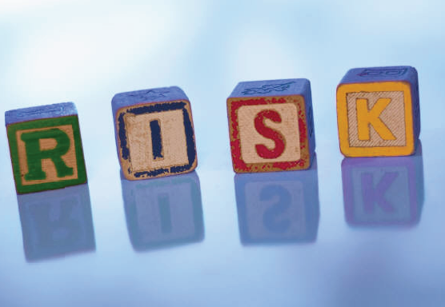

MCHD’s Anti-Fraud Strategy

- Prevention
- Education and Training
- Detection and Investigation
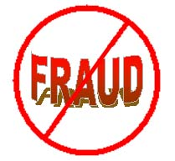
- Reporting Fraud
- Establishment of a Fraud and Abuse Compliance Committee
- Designating a Fraud and Abuse Compliance Officer
Fraud and Abuse Compliance Committee (FACC)

- To ensure MCHD meets all the requirements, the HD has created a Fraud and Abuse Compliance Committee
- Includes representation from all Divisions
- Responsible for ensuring reporting methods and trainings are available
- Participates in investigations and early detection



Marion County Health Department

Health Care
Fraud and Abuse
“Understanding the Consequences”

Marion County Health Department

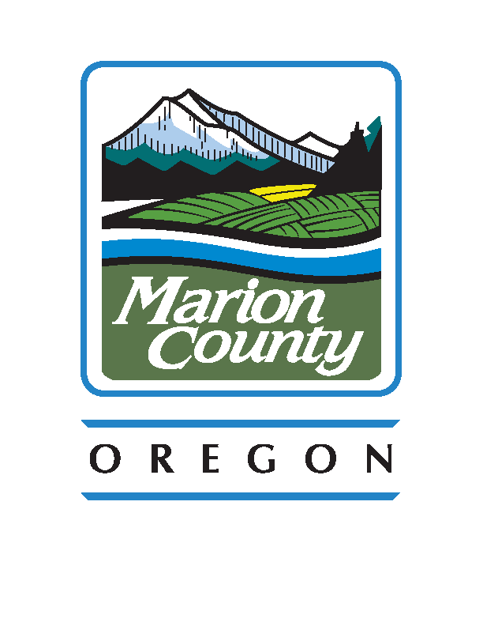

Mission

- To review and investigate all allegations of fraud and/or abuse, whether internal or external, to take corrective action for any supported allegations, and to report misconduct to the appropriate parties.
- MCHD is committed to the development and implementation of an aggressive prevention, detection, monitoring and investigation program to reduce fraud and abuse.
Training

- Marion County Health Department is required by Federal Mandate to make available Fraud and Abuse training for all employees and contracted providers
What is Fraud?

- The intentional deception or misrepresentation made by a person with the knowledge that the deception could result in some unauthorized benefit to him/herself or some other person
What is Abuse?

- Practices that are inconsistent with sound fiscal, business, or medical practices and result in an unnecessary cost to Medicaid, Medicare or the MVBCN, or in reimbursement for services that are not medically necessary or that fail to meet professionally recognized standards for health care



Whose Problem is it?

- Health Care Fraud Impacts Everyone
- While one in four American say it’s OK to defraud insurers, consumers need to understand this type of thinking is costly and results in rising health care costs
- The average American household pays $1,000 every year in out-of-pocket-costs as a result of insurance fraud
- Seniors and taxpayers pay up to $1 billion a year in inflated drug prices due to potential fraud and loopholes in Medicare, representing 1/5 of Medicare spending in 2000
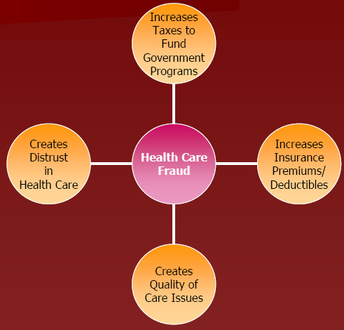
Types of Fraud

- Billing for services not provided (i.e. phantom services)
- ‘Up-coding’ or ‘down-coding’
- Inappropriate documentation for services rendered
Fraud Indicators

- Limited time spent by providers with patients
- Inadequate treatment plan
- Consistently poor outcomes may be a sign of lack of treatment
- Unusual patient encounter ratios
What Laws Regulate Fraud?

- False Claims Act (FCA)
- HIPAA
- Deficit Reduction Act
- The False Claims “Whistleblower” Employee Protection Act
- Administrative Remedies for False Claims and Statements
Reporting Protection

- A company is prohibited from discharging, demoting, suspending, threatening, harassing or discriminating against any employee who, in good faith, reports acts of fraud or abuse
Requirements

- Employees are obligated to report potential fraud and abuse
- Anyone referring a matter to the Fraud and Abuse Compliance Committee or Compliance Officer has the right to remain anonymous

