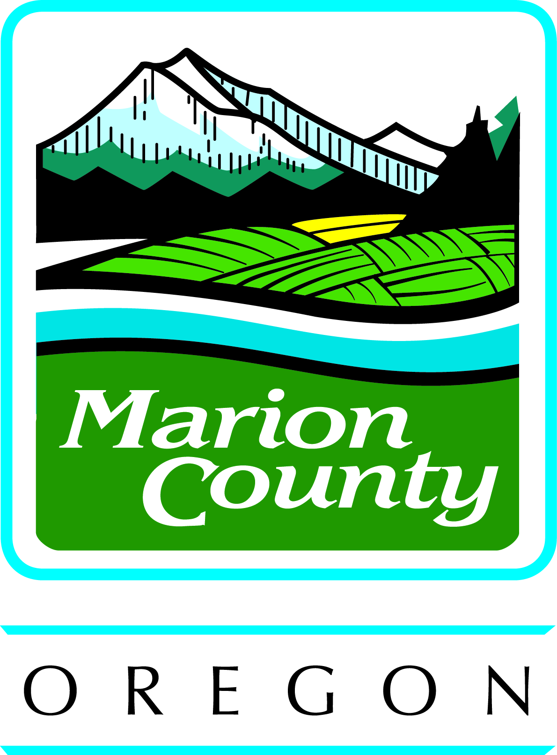
MARION COUNTY BOARD OF COMMISSIONERS

Wednesday, March 18, 2015
Board Session 9:00 a.m.

Courthouse Square
555 Court Street NE, Salem

PRESENTATION

Asphalt Pavement Association of Oregon Urban Street Award to Public Works Engineering Staff. – Alan Haley, Cindy Schmitt, and Steve Preszler

PUBLIC COMMENT

CONSENT

BOARD OF COMMISSIONERS
Approve a resolution supporting Second Amendment rights in the United States Constitution and Article 1, Section 27 rights in the Oregon Constitution.

PUBLIC WORKS
Receive hearings officer’s recommendation and schedule a public hearing for April 1, 2015, for zone change/comprehensive plan amendment, case #ZC/CP 14-002, Freres Timber, Inc.

TAX COLLECTOR
Approve an order authorizing property tax refund to T-Mobile USA, Inc., in the amount of $20,486.34.

ACTION

BOARD OF COMMISSIONERS
1. Consider approval of an order appointing Kim Brady to the Marion County Veterans Task Force. – Commissioner Carlson

2. Consider approval of an order adopting revisions to policy #704, Social Media Use. – Jolene Kelley, Noah Olson, Morgan LaFrance

PUBLIC HEARING
9:30 A.M.

None.

*********************************************************************************
If you require interpreter assistance, an assistive listening device, large print material or other accommodations, call 503-588-5212 at least 48 hours in advance of the meeting. TTY 503-588-5168 Si necesita servicios de interprete, equipo auditivo, material copiado en letra grande, o culaquier otra acomodacion, por favor llame al 503-588-5212 por lo menos 48 horas con anticipacion a la reunion. TTY 503-588-5168 Marion County is on the Internet at: www.co.marion.or.us

