Economic Development Lottery Grants
See website for due dates
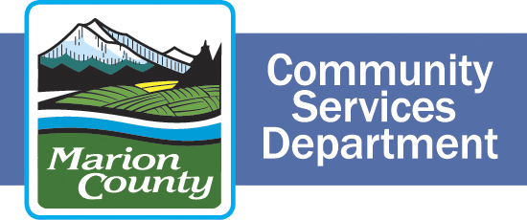

ATTACHMENT B – ASSURANCES

Organization Name:

My signature below indicates that I understand that if my business is awarded funds under this application I will:
- Agree to specific measurements that can identify the effectiveness of my project.
- Provide proof of secured revenue prior to release of grant funds if required by County.
- Agree to a Money-Back Guarantee on grant funds.
- Allow Marion County to disclose limited company information (non-proprietary) on the type and amount of grant awarded by Marion County, the benefits my company has committed to create relevant to this grant program, and the outcome of fulfilling those commitments.
- Track expenditures related to this project separately from other organizational funds, and provide reports at specified intervals agreed upon in the contract.
- Complete project reports as outlined in the contract, including a final report at the end of the project providing both anecdotal information and data on the project’s outcomes. (Final payment will not be made until a final report is accepted and reviewed by the Marion County Economic Development Advisory Board.)
- Maintain sufficient resources on hand to cover project costs incurred between invoices. (Invoices may be submitted once each month, or as negotiated.)
- Sign a Contract before funds are delivered and comply with the terms and conditions therein for the duration of the project.
- Have the authority to sign this application on behalf of my organization.

Printed Name of Authorized Agent |  | Title
Signature of Authorized Agent |  | Date

