Early Childhood Nursing
3180 Center St NE Suite 1360
Salem, OR 97301
Main Number: 503-373-3781
Fax number: 503-566-2948
www.co.marion.or.us/HLT/PH/ECT

Free home visiting services by public health nurses:
- For:
  - pregnant women
  - children (0-21 years)
  - and their families.
- Visits are voluntary and ongoing to meet family needs
- English and Spanish speaking staff
- Interpretation is available for other languages.

Services- Nurses promote physical, social, and emotional health through…
- Education about pregnancy, parenting, nutrition, safety, and child development
- Medical guidance on accessing the health care system and understanding health conditions
- Finding and using local resources: WIC, immunizations, health care, early intervention, therapies, insurance assistance, DHS services such as Self Sufficiency and Developmental Disabilities, and more
- Screenings and assessments for pregnant/postpartum women and children
Referral Process
We accept referrals via phone, fax, or mail. Referral forms are on our website. www.co.marion.or.us/HLT/PH/ECT
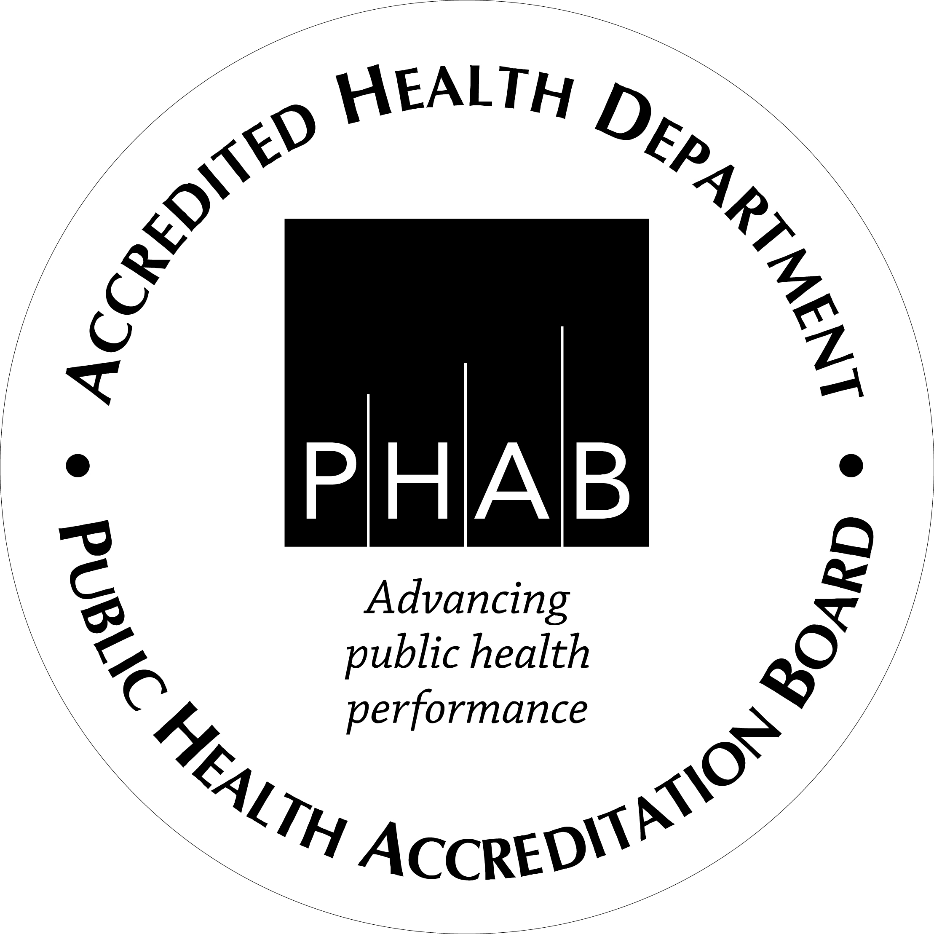
Early Childhood Nursing
3180 Center St NE Suite 1360
Salem, OR 97301
Main Number: 503-373-3781
Fax number: 503-566-2948
www.co.marion.or.us/HLT/PH/ECT

Free home visiting services by public health nurses:
- For:
  - pregnant women
  - children (0-21 years)
  - and their families.
- Visits are voluntary and ongoing to meet family needs
- English and Spanish speaking staff
- Interpretation is available for other languages.

Services- Nurses promote physical, social, and emotional health through…
- Education about pregnancy, parenting, nutrition, safety, and child development
- Medical guidance on accessing the health care system and understanding health conditions
- Finding and using local resources: WIC, immunizations, health care, early intervention, therapies, insurance assistance, DHS services such as Self Sufficiency and Developmental Disabilities, and more
- Screenings and assessments for pregnant/postpartum women and children
Referral Process
We accept referrals via phone, fax, or mail. Referral forms are on our website. www.co.marion.or.us/HLT/PH/ECT

