

TEMPORARY RESTAURANT APPLICATION
THIS LICENSE CAN ONLY BE ISSUED IN CONJUNCTION WITH A TEMPORARY COMMUNITY EVENT
AT LEAST ONE PERSON WITH A FOOD HANDLER CARD MUST BE PRESENT AT ALL TIMES

Single Event License (up to 30 days) |  | Seasonal License (up to 90 days | see back page)
Benevolent → Non-Profit Tax ID#: _______________________  For profit Out of County Mobile Unit: _________________  Contiguous to facility (operating directly outside your restaurant) |  | Intermittent License (up to 30 days | see back page)
 |  | Operational Review: included on file

Event Name: | Dates of Event:
Event Address: | Hours of Operation:
Event Organizer: | Organizer’s Phone:
Food Booth Name: | Email:
Owner or Person in Charge of Booth: | Phone:

Mailing Address:

All food must be prepared at the event or in a facility approved by the Health Department or the Department of Agriculture.
Where is food being purchased? |  | Water Source: | Public (city)  Private (local well)

Where will dishwashing take place?

Name & Address of facility used for off-site food prep (if applicable)?

Do you have the following? (see back page for details)

Food thermometer Sanitizer test paper Temporary handwashing station Oregon Food Handler Card

Menu: Food item | How served  Hot Cold |  | Made to order  Yes No |  | Preparation |  | Temperature Control Method (Refrigerator, grill, ice cooler, etc)
Menu: Food item |  |  |  |  | Off-site On-site

SPECIFIC PROBLEM(S) / REQUIRED CORRECTION(S) / COMMENTS
____________________________________________________________________________________________________________________________________________________________________________________________________________________________________________________________________________________________________________________________________________________________________________________________________________________________________________________________________________________________________________________________________________________________________________________________________________________________________________________________________________________________________________________________________________________________________________________________________________________________________________________________________________________________________________________________________________________________________________________________________________________________________________________________

DO NOT WRITE IN THIS SPACE (rev 1/25) License Expiration Date: __________________

FEE OF $____________________________________________ RECEIPT # _______________________________________ DATE ___________________________

OPERATOR__________________________________________ EHS_____________________________________________ DATE___________________________
Phone Consultation (Benevolent)

License Types:
- BENEVOLENT TEMPORARY RESTAURANT - Non-profit organizations having a Tax-Exempt ID number (e.g.; churches, volunteer groups, little leagues.)
- OUT OF COUNTY MOBILE UNIT – A mobile unit currently licensed in the State of Oregon. A copy of your mobile unit license must be submitted or emailed with your application. Off-unit tables and display areas may be used to store/dispense non-potentially hazardous foods, beverages, condiments, and single-use utensils. Off-unit freezers may be used if they maintain food in a frozen state (OAR 333-162-0036). If food preparation or assembly will take place off the unit, then a standard temporary restaurant license must be obtained.
- INTERMITTENT LICENSE – A temporary restaurant that will operate at one location in connection with multiple public gatherings/events that are arranged by different oversight organizations. The menu must remain the same.
- SEASONAL LICENSE - A temporary restaurant that will operate at one location in connection with one or multiple public gatherings/events that are arranged by the same oversight organization. The menu must remain the same.

LICENSE IS ONLY VALID FOR LOCATION/EVENT(S) FOR WHICH IT IS ISSUED.
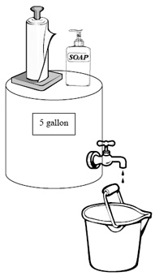
Home Prepared Food Is Not Allowed.

Handwashing Set Up

Set up the handwashing facility FIRST! This must be done before food preparation begins.
Use a sink with warm running water or provide a 5-gallon container of warm water with a dispensing valve that provides a constant flow of water when opened (push button type not allowed). A container must be provided to catch the wastewater. Provide dispensed soap and paper towels. Wash hands for 15 to 20 seconds. Do not use cloth towels to dry hands.
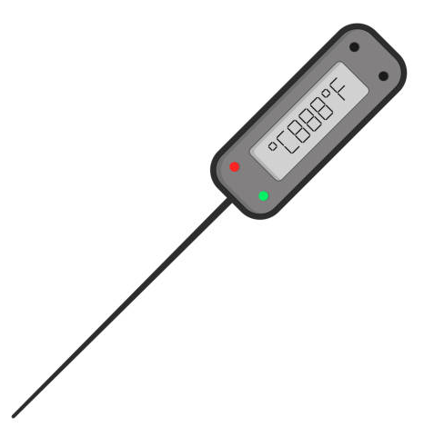
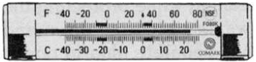
Thermometers

Probe thermometers are required to test food temperatures when holding food hot or cold or when cooking raw animal products. A small diameter probe is required to measure the temperature of thin foods, such as burgers and fish fillets. Refrigerator thermometers are required in all refrigerators or coolers.

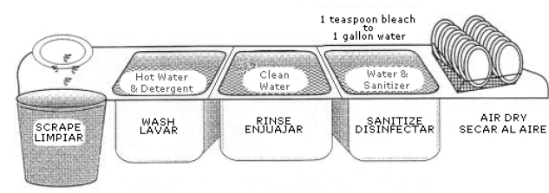
Dishwashing

A commercial dishwasher, three-compartment sink, or three buckets may be used to clean dishes/utensils. All equipment and utensils must be washed, rinsed and sanitized using a three-step process: First, wash with hot soapy water. Second, rinse with hot water. Third, submerge in sanitizer (50-100 ppm for 10 seconds for chlorine bleach, 200-400 ppm for 30 seconds for quaternary ammonium) and air dry. Test strips are required to monitor sanitizer concentration.

FEES & SUBMITTALS

FEES ARE SUBJECT TO CHANGE ANNUALLY.
NOTE: A $25 NON-REFUNDABLE ADMINISTRATIVE FEE IS INCLUDED IN THESE FEES.
FOR AN UPDATED FEE SCHEDULE, VISIT OUR WEBPAGE: https://www.co.marion.or.us/HLT/PH/EHS/Pages/rules.aspx

APPLICATION RECEIVED LESS THAN 5 BUSINESS DAYS PRIOR TO THE EVENT WILL BE CHARGED A LATE FEE
For Profit Late Fee = $100 Benevolent Late Fee = See Fee Schedule

THIS APPLICATION MUST BE COMPLETED IN FULL AND SUBMITTED WITH FEE:

In-Person  Monday-Friday 8:30am-4:30pm | By Mail  Marion County Environmental Health  3160 Center Street NE Salem, OR 97301  ▪ PAY BY CHECK ▪ | By Email  EnvironmentalHealth@co.marion.or.us  PAY ONLINE, BY *PHONE*, OR BY ▪CHECK▪

▪ MAKE ALL CHECKS PAYABLE TO: MARION COUNTY ENVIRONMENTAL HEALTH OR “MCEH” ▪

*FOR PHONE PAYMENTS, CALL OUR OFFICE AT (503)-588-5346, MONDAY - FRIDAY FROM 8:30AM - 4:30PM*
THERE IS A 2.65% SERVICE FEE FOR ALL DEBIT/CREDIT CARD PAYMENTS

