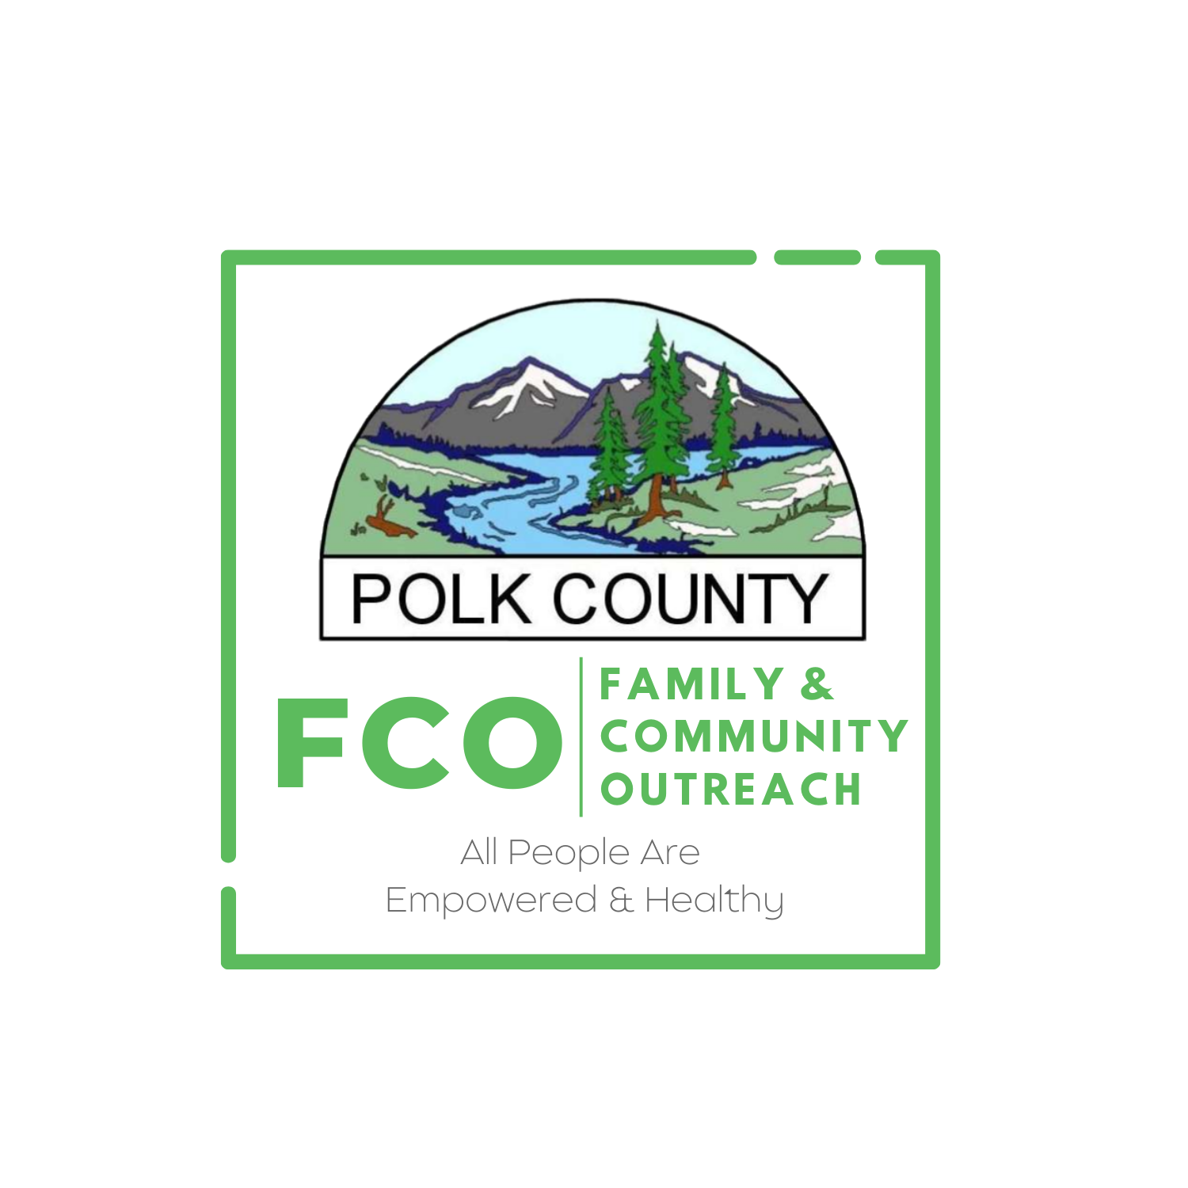

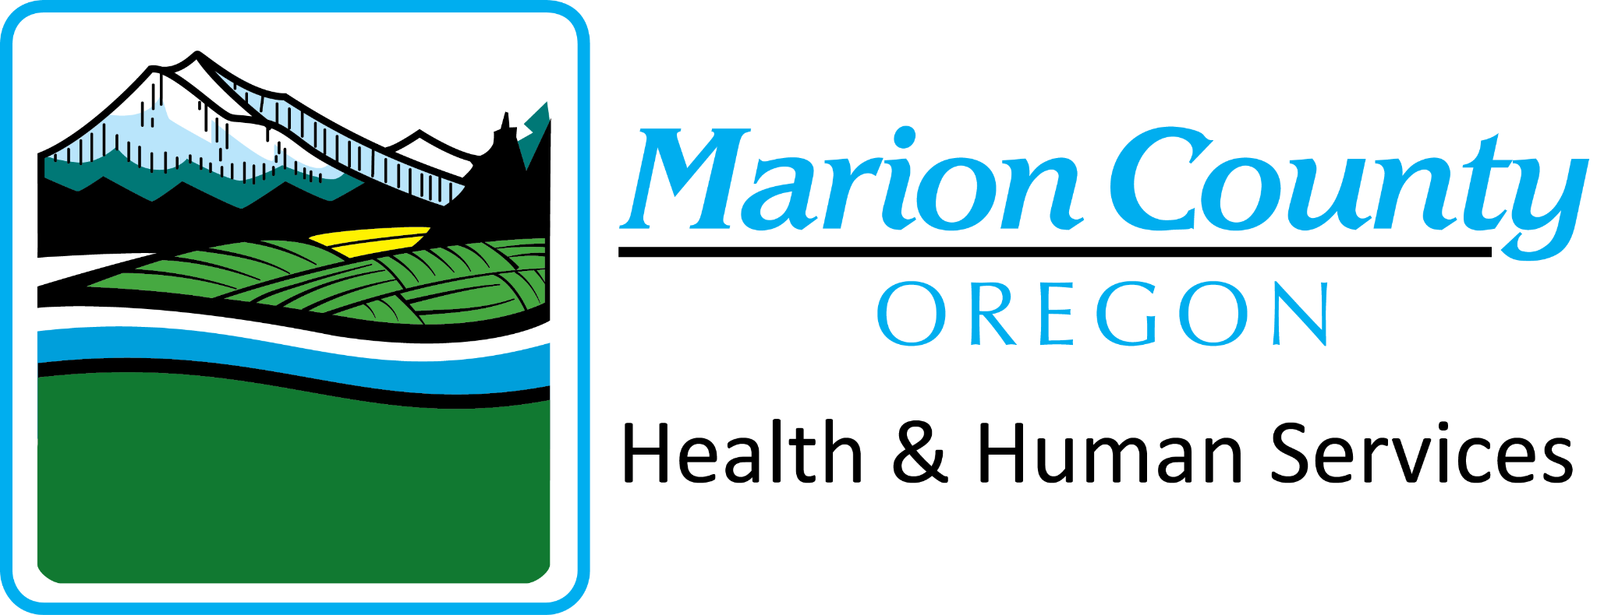
2026 Healthy Choices Video Contest

PRIZE BREAKDOWN:
- 1st place: $1,000 total. $800 Visa gift card to participants, $200 Visa gift card to the eligible supporting organization (see page 2 for details).
- 2nd & 3rd place: $500 total. $400 Visa gift card to participants, $100 Visa gift card to the eligible supporting organization.
- Multicultural Inclusivity Award: Special recognition will be given to videos submitted in a language other than English. For example: American Sign Language, Spanish, or other languages.
- Community Choice Award: Special recognition will be given for the video with the most public votes.
Step 1: Create Your Team.
- Group of 2-4 friends (14-18 years old).
- Adult advisor at school or from community organization.
Step 2: Pick a message for your video that focuses on healthy choices.
- Video must include resources for youth.
- The video should be from youth voice and youth perspective.
- Be creative! Potential video ideas:
  - A video about a time when you’ve been faced with a tough choice and chose the healthy route instead.
  - Make a mini documentary on something you’ve accomplished & the work it takes to get there.
  - Have a talk show/interview style video about healthy choices.
  - Create a PSA for other youth on how healthy choices impact your future.
  - Share an informational video on ways you calm down when stressed.
Step 3: Create Your Video.
- 1-4 minutes run time
- Needs to depict healthy activities & messaging.

Do not imitate gambling, alcohol, or drug use.

Do not show depictions of violence, self-harm, weapons, or use inappropriate language.

Use person centered language (example: person with a gambling problem or person with a drinking disorder, NOT problem gambler or alcoholic).
- Videos in languages other than English will be accepted! If submitting a video in another language, please have English subtitles accompany your film.

Step 4: Submit Your Video, Registration and Photo Release Forms
- Upload your video by midnight on January 14th, 2026. Email Hejohnson@co.marion.or.us to receive a link to upload your video.
- Submit completed registration form and photo release forms to Heidi Johnson, Hejohnson@co.marion.or.us on or before January 14th, 2026.

See the following pages for additional contest details, the registration form and photo release form.
For questions or more info, please contact Heidi Johnson, Hejohnson@co.marion.or.us

IMPORTANT DATES:
January 14th, 2026: | Submit your video and release/permission forms to Hejohnson@co.marion.or.us
January 19th, 2026: | Top Submissions (judged by committee) will be posted for voting. Share with your family & friends.
January 25th, 2026: | Public voting ends.
January 31st, 2026: | Red carpet award event for top 3 videos

ELIGIBILITY:
The contest is open to high school age teenagers (14-18 years old) living in Marion County or Polk County, Oregon, and/or affiliated to an eligible supporting organization based in either county. Eligible supporting organizations include Marion and Polk County based school districts and affiliated classes, clubs, sports teams, and groups; or a not-for-profit community-based organization that serves youth. Exceptions may apply, contact us for more information.

Important Details:
- Copyright: Same copyright rules as YouTube (http://www.youtube.com/yt/copyright/faq.html). Participants must secure written consent to use any music or images that are not original or in the public domain (entries may be disqualified without proper consent).
- The video must be submitted by an adult advisor with an eligible sponsoring organization; this person must ensure that the attached photo release form (see page 4) is signed for each person appearing in the video. (This includes shots of the general public, lunchrooms, etc.). Videos submitted without photo releases will not be eligible.
- We reserve the right to use submitted videos for promotional or educational purposes. The videos become property of both Marion County and Polk County once submitted. Titles and minor editing are subject to modification.

2026 Healthy Choices Video Contest Registration Form
Eligibility: The contest is open to high school age teenagers (14-18 years old) living in Marion County and Polk County, Oregon, and/or affiliated to an eligible sponsoring organization based in Marion or Polk County. Eligible supporting organizations include Marion County and Polk County based school districts and affiliated classes, clubs, sports teams, and groups; or a not-for-profit community-based organization that serves youth.
Contest registration and videos must be received by January 14th, at midnight. Email completed form and any questions to Heidi Johnson, at Hejohnson@co.marion.or.us

CONTACT INFORMATION
Name of youth participants:
Video project name:
Messaging Topic chosen:
Will your video include any of the following: in a language other than English,
American Sign Language, or represent persons with a disability/varying abilities? Yes or No:__________________
Name of sponsoring organization:
Adult advisors name:
Contact phone number:
Contact email address:
Brief description of project:

Adult Advisors’ signature:
(Electronic signature is okay)
Date/Time Submitted:

2026 Healthy Choices Video Contest
Photo Release
Return this form when you submit the video of your project. Everyone appearing on-screen or vocally recorded will need to sign, or have their parents sign if they are under the age of 18. Multiple photo release forms may be submitted with one video project.
I, the undersigned, affirm that I wish to participate in the 2026 Marion and Polk County Healthy Choices Video Contest. I am aware that as part of this contest my voice and image may be used in a video intended to increase awareness. I give my permission to Marion County, Polk County, and Capital Community Media to use my own or my child under 18’s image, audio, and video for educational or awareness raising purposes.
Name of sponsoring organization:
Video Project Name:

 | Name: (anyone recorded, audio/visual) | Date: | Signature: (parent/guardian if under 18)
1.
2.
3.
4.
5.
6.
7.
8.
9.
10.
11.
12.

