Getting ready for your waste audit
A waste audit is a fun activity that helps the kids learn about how much and what kinds of waste their school is making. After we finish, we’ll analyze the results & use that information to:
- Determine largest components of the school’s waste stream.
- Target what areas of the school to focus on.
- Build a case for waste reduction & recycling/composting.
- Educate the school staff & students. Some classes have used the results of these "waste studies" to create school-wide competitions, share the results in school assemblies and newsletters, and create posters to hang up in the hallways as a part of their outreach to the rest of the school.
- Compare your progress as you implement new programs.
- Work with the garbage/recycling hauler to make program changes.
- Gain credibility when making suggestions for change.
- Use it as documentation in your Oregon Green Schools application.

So, here's what you'll need to do beforehand:
1) Get the principal's permission to do the activity if necessary.

2) Talk to the custodian & explain what you're planning.

3) Decide what part of the school to target. If you want to keep things simple, I'd suggest setting aside the garbage from the day before from the office, two separate hallways, and 4 randomly selected classrooms. No bathroom garbage, and don’t go overboard with too much cafeteria waste as it’s messy.

Another option that would give you a more accurate picture of what is being thrown out is to ask the custodian to keep all of the garbage that was generated the day prior to the audit and to keep the garbage from the areas listed below in distinct piles. Even if you don’t sort through it all, you can at least get an idea of where it is being generated & you can measure the weight & volume. This is the preferred method of doing it if your custodians can accommodate the request.
- Bathrooms (this will not be sorted but you can still weigh it & measure the volume)
- Classrooms, offices, library, etc.
- Hallways
- Cafeteria (student lunch waste)
- Kitchen (pre-student waste)
- Events (if there was a sporting event, play, etc. the day before)
- Teachers’ Lounge (some schools create competitions between students & staff)

4) Tell as few people as possible what you are planning...this way the sample is untainted. If everyone knows that you will be measuring their trash, it could change what they put in!

5) At the end of the day prior to the waste audit, go around and collect the garbage from the areas that you will be analyzing. Be sure that you've coordinated this with the custodian so that these bags don't get dumped. Ask him/her where to store them until the sort. It’s helpful if you can label where the trash came from so that you can compare different sources within the school.

6) Gather supplies for the audit:
- Gloves (Nitrile, variety of sizes)
- Clipboard
- 10’ x 10’ tarp & dustpan with little brush
- Scale (the kind used to weigh fish work better than bathroom scales)
- Transparent bags

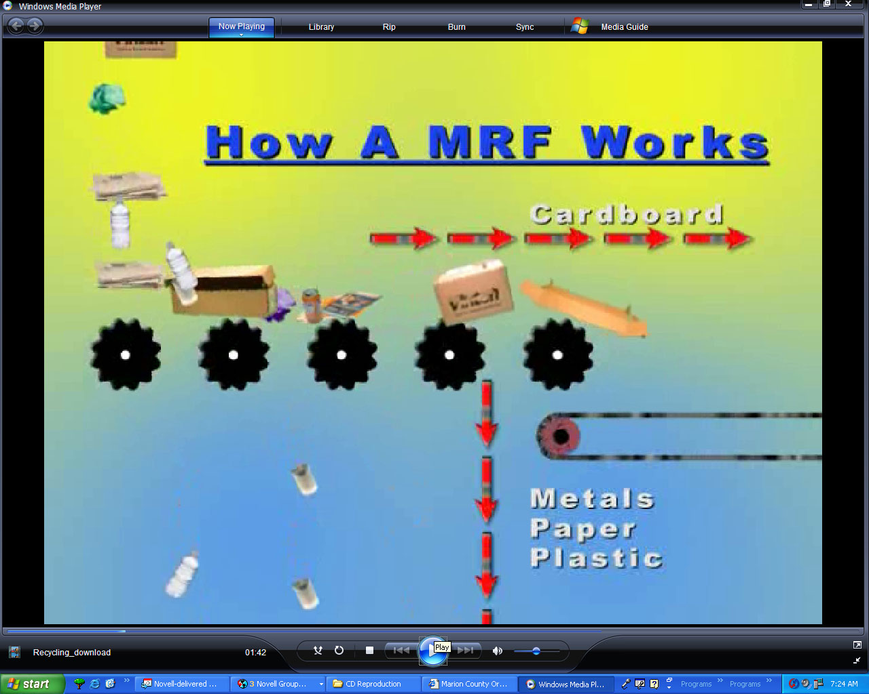
It’s easiest if you have these materials set up ahead of time.

Steps for conducting the waste audit:
- Bring props to introduce the activity to the kids. Start out by asking them why recycling is important and what happens to the recycling when the garbage/recycling hauler takes it away. I like to show them some laminated photos that illustrate the recycling process.
- Explain that many businesses, counties and state government do periodic studies to determine what’s in the garbage. Ask them why this is done. It helps us know what things we should be putting our resources towards so that they are recycled instead of wasted as garbage. I like to show them a simplified pie chart of a waste characterization study.
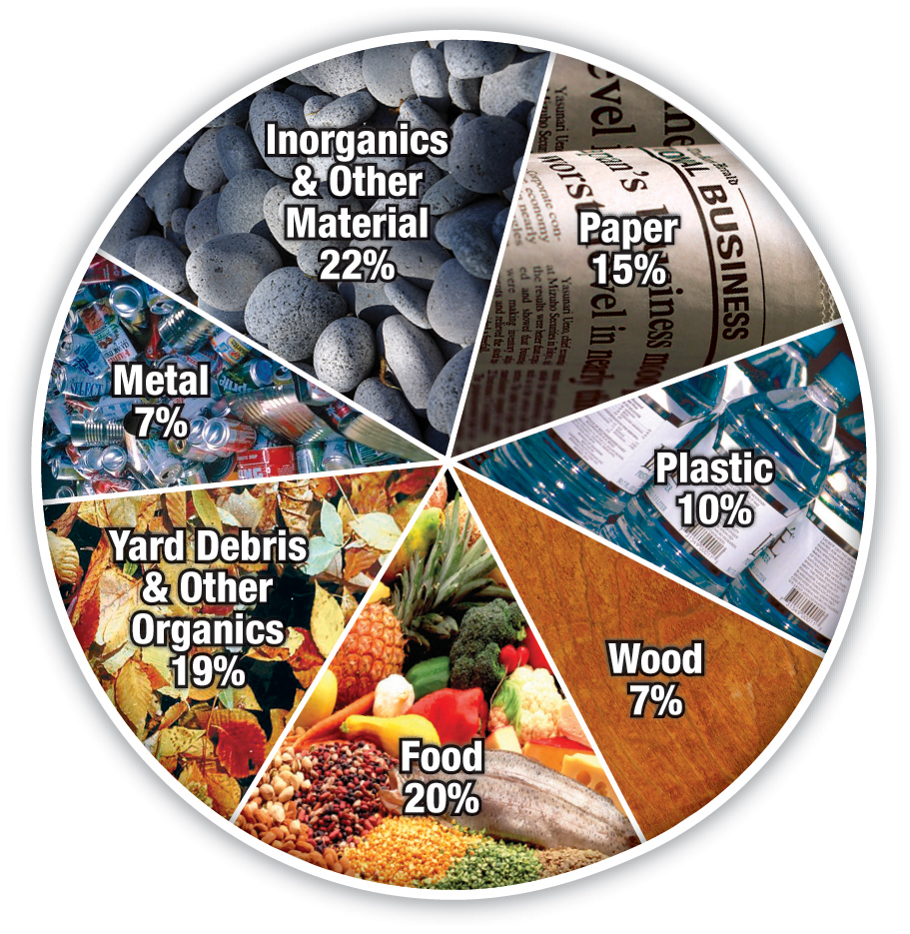
- Start out doing one bag &/or area at a time so that you can make distinctions between cafeteria waste, classroom waste, hallway waste, etc.
- Begin by having the kids spread out around the outside of the tarp and put on gloves. Then walk around and explain what types of items belong next to each sign (like the examples below to the right) as you place them around the edge of the tarp. Tell the kids that they should use their best judgment and not ask you if something is recyclable. You’ll go over the results afterwards.
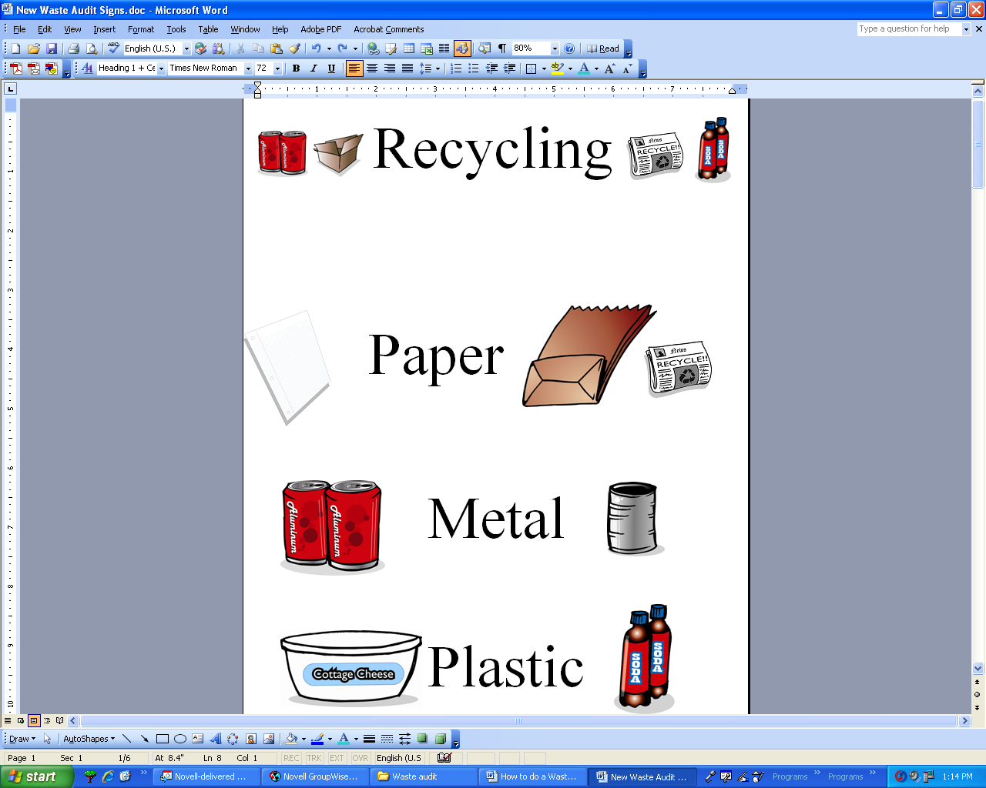
- When the kids have finished, have them spread out on the periphery of the tarp again and go from one pile to the next making any corrections that you see.
- Next ask them to help you estimate the volume of each pile while two assistants bag the material and weigh it using the scale. Write down the class’ estimations of volume on the form. They usually need help with this. You may want to bring a five gallon bucket or a milk jug to contextualize the size of a gallon. This is why it’s important to use transparent bags.
- There are various versions of the waste audit forms. Use the one that you feel most comfortable with and feel free to modify the layout to customize it to your school.
  - If you use the Excel version of the waste audit form, you will need to later transcribe the notes you took onto the spreadsheet and it will automatically generate pie charts showing the categories by volume & weight. The form is customizable so that you can change the categories to fit your particular circumstances.

Other tips…
- Don’t try doing the audit outside unless it’s a dry, calm day.
- Be sure to recycle everything afterwards. It sends the wrong message to the kids if you turn around and throw the recyclables that you’ve just sorted out into the trash!
- Encourage teachers to integrate the results of the waste audit into their curriculum if possible (i.e. writing a letter to the principal or custodian, present the information to other classes, fractions and percentages, etc.).
- Sometimes I give little goodies (recycled pencils, stickers, etc.) to kids that stay around afterwards to help me clean up and pack up the kit.
- Consider also tracking how full your dumpster is on the afternoon or morning before it is emptied. If you do this periodically throughout the year, you’ll be able to determine if you are indeed throwing away less and if so if it’s possible to reduce the size of the dumpster or frequency of the pick-up schedule. This could be a big money saver.

Glad to see your enthusiasm for environmental protection! Call me if you have any questions. Keep up the good work.

