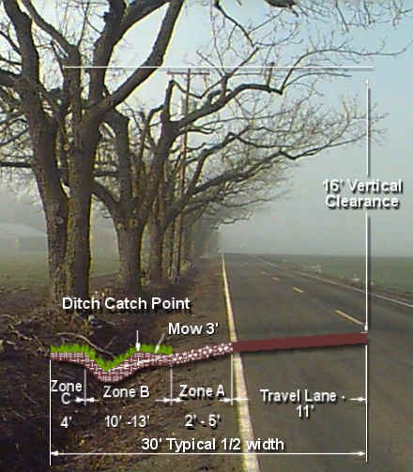

/tmp/in/input.doc

Roadside Vegetation Maintenance
Typical cross section *Not to scale

- Zone A
  - Spray – Vegetation Free
  - Spray width based on type of road
    - 2’ for local
    - 3’ for collectors
    - 5’ for arterials

- Zone B
  - Mow to ditch catch point (May – Oct.)
  - Brush every 7 years (Sept. – Oct.)
  - Spot-spray brush (e.g. poison oak, blackberries, Scotch broom)
  - Clean ditches (Approx. 15-yr. Cycle)

- Zone C – Behind Ditch
  - Maintenance free except the following:
    - Emergency and/or dangerous circumstances
    - Vision hazard as needed
    - Vegetation in zone “C” is encroaching into zone “A” or “B”, within 16 ft. vertical of maintenance (e.g. shoulder grading and ditch cleaning)
    - Tree limbs overhanging into the roadway or zone “A” will be trimmed flush to the beginning of zone “C”

*Except where vegetation management agreement exists with abutting property owners
*Rural vertical clearance 16”
*Urban vertical clearance 14”

