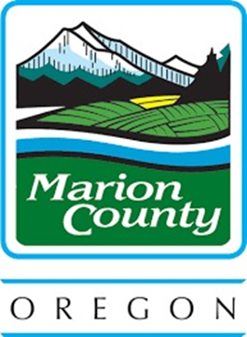

CDBG/HOME PROGRAM
Residential Anti-Displacement and Relocation Assistance Policy

Marion County Board of Commissioners Office

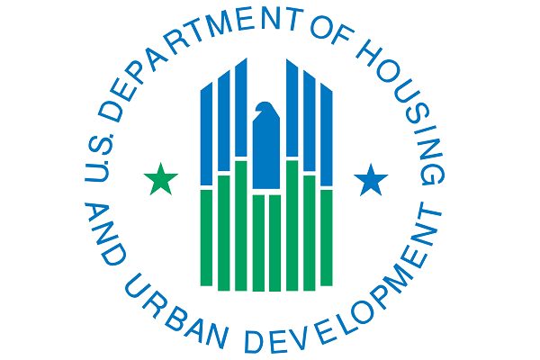
Marion County administers federal funds from the U.S. Department of Housing and Urban Development (HUD) under a HUD-approved Consolidate Plan for Housing and Community Development. This “Residential Anti-displacement and Relocation Assistance Plan” is required for both the HOME Investment Partnerships Program (HOME) and the Community Development Block Grant (CDBG) Program.
Part A: Programs Covered by Policy
1. HOME Invest Partnership Program (HOME)

- Statutory Requirement: Section 105(b)(14) of the Cranston-Gonzalez National Affordable Housing Act (NAHA)
- Program Regulations: 24 CFR Part 92.353 (Displacement, Relocation and Acquisition) and 24 CFR Part 42 (Displacement, Relocation Assistance, and Real Property Acquisition for HUD and HUD-Assisted Programs)
- Responsible for Enforcement: Marion County Board of Commissioners

2. Community Development Block Grant (CDBG)
- Statutory Requirement: Section 104(d) of the Housing and Community Development act of 1974.
- Program Regulations: 24 CFR Part 570.606(c) (Displacement, relocation and acquisition, and replacement of housing) and 24 CFR Part 42 (Displacement, Relocation Assistance, and Real Property Acquisition for HUD and HUD-Assisted Programs).
- Responsible for Enforcement: Marion County Board of Commissioners.

Part B: Steps to Minimize Displacement
The County will minimize the displacement of families and individuals from their homes and neighborhoods as a result of Community Development Block Grant activities by requiring recipients of program funds to take the following steps, consistent with other goals and objectives of programs covered by 24 CFR Part 92 and 24 CFR 570.
- Seek unimproved or vacant properties for project activities to eliminate displacement of tenants.
- Stage rehabilitation of multi-family projects to allow tenants to remain in the building/complex during and after the rehabilitation, working with empty units first.
- Arrange for facilities to house persons who must be relocated temporarily during rehabilitation.
- Provide counseling assistance to assist homeowners and renters in understanding the range of assistance that may be available to help them stay in their neighborhood.
Part C: Relocation Assistance for Displaced Persons
Marion County will be required to provide relocation assistance in accordance with 24 CFR Part 42.350 if a project that is funded requires the relocation of tenants/recipients.
Part D: One-For-One Replacement of Lower-Income Dwelling Units
Marion County will ensure that recipients comply with the requirements of 24 CFR Part 42.374 and 24 CFR Part 42.375 for the replacement of all occupied and vacant occupiable lower-income dwelling units that are demolished or converted to another use other than as lower-income dwelling units in connection with Community Development Block Grant assisted activity.
If funds will be used for any activity that will directly result in the demolition of lower-income dwelling units or the conversion of lower-income dwelling units to another use, Marion County will require the Community Development Block Grant recipient to make public in writing the following information:
- A description of the proposed activity.
- The location on a map and number of dwelling units by size (number of bedrooms) that will be demolished or converted to another use other than for lower income dwelling units as a direct result of assisted activity.
- A timeline for the commencement and completion of the demolition or conversion.
- A map indicating the location and the number of dwelling units by size (number of bedrooms) that will be provided as replacement dwelling units. If such data is not available at the time of the general submission, the submission shall identify the general location on an area map, the approximate number of dwelling units by size and information identifying the specific dwelling units by size and shall be submitted and disclosed to the public as soon as it is available.
- The source of funding and a timeline for the provision of replacement dwelling units.
- The basis for concluding that the replacement housing will remain a lower income dwelling unit for at least 10 years from the date of initial occupancy; and
- Information demonstrating any proposed replacement of dwelling units with smaller dwelling units is consistent with the needs assessment contained in the Consolidated Plan. A sub recipient or the County will need to make public information demonstrating that the proposed replacement is consistent with the housing needs of lower-income households in the jurisdiction.

The above information shall be submitted before funds are committed by Marion County for any Community Development Block Grant activity.

